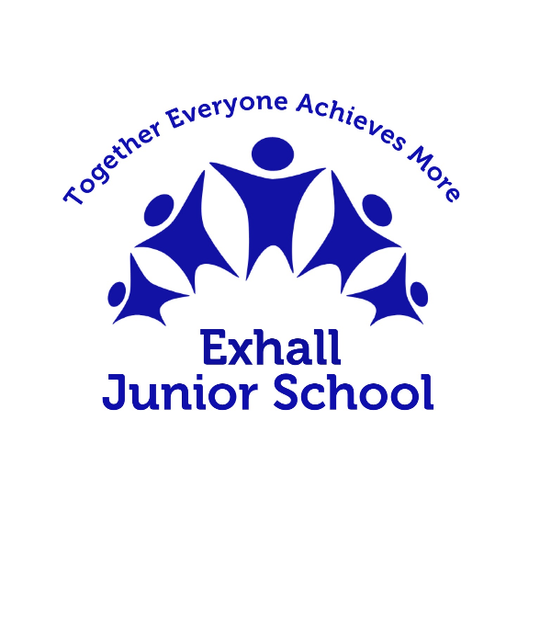

# Curriculum Offer

# Physical education

| Statement of Intent |
| --- |
| At Exhall Junior School, we recognise the importance of Physical Education to a child’s physical, cognitive, social and emotional development, as well as the role it can play in a child’s spiritual, moral and cultural development.  Physical Education develops children’s knowledge, skills and understanding, so that they can perform with increasing competence and confidence in a range of physical activities. It promotes an understanding of the body in action and encourages positive attitudes towards a healthy lifestyle. Children will learn how to apply all skills taught throughout their school journey in isolation and combination. They develop an understanding of how to improve, evaluate themselves and others and recognise their own success.  We aim to provide a broad and balanced P.E. curriculum to aid children’s increasing self-confidence to manage themselves and their bodies within a variety of movement situations. A balance of individual, team, cooperative and competitive activities aim to cater for individual pupil’s needs and abilities. Daily physical activity and health enhancing activities also play a crucial role in our offer to pupils. This includes: active lessons, active break and lunchtimes and extra-curricular activities.  House teams within school enable pupils to engage in friendly competition and receive collective rewards for **Safe, Ready and Respectful** behaviours within sport and across the wider school. This promotes positive sporting values in line with our core school values. |

| Special Educational Needs (SEND) / Pupil Premium / Higher Prior Achievers |
| --- |
| * Pupils with special educational needs and/or disabilities (SEND) are supported to achieve well in PE through differentiated approaches where necessary. While specific strategies may be implemented, the curriculum remains ambitious and inclusive for all. * For those who require support to develop motor skills and balance, specialist teachers provide the MOVES programme, developed by South Warwickshire University NHS trust, to develop gross motor skills and coordination. * Pupil Premium funding is utilised to enable our Pupil Premium students to experience additional sporting activities, such as Urban Strides, Skip2bFit and Strong Girls Can workshops. Our Pupil Premium students are given priority access to such events. * Prior higher achievers are encouraged to engage in competitive sport at local and county level. |

| Implementation |
| --- |
| In our school, all children receive P.E in the following way:   * A minimum of one hour of planned and protected Physical Education lessons where opportunities for pupils to engage in sustained physical activity are maximised. * A broad, balanced multi-skills approach, building on early physical literacy skills developed in EYFS and Key Stage 1. * Sequential learning with logical progression - allowing pupils to practice, refine and revisit content before learning new and more complex skills, securing prior learning and building confidence throughout KS2, ensuring pupils are ready for secondary education. * Pupils are taught safe, efficient and intelligent movement. They are also taught important health-related knowledge to help them make informed decisions about how to live a healthy, active life. * Frequent opportunities are provided to allow pupils to engage in competitive sport, both against themselves and others. As members of the Bedworth School Sports Association and School Games, our pupils can experience friendly competition against other local schools in a variety of sports. * In year 3, our pupils are taught to swim at the local leisure centre in accordance with National Curriculum guidance. * Regular in-school sporting events aimed at inspiring non-active pupils, including workshops from external providers, sports days, themed days of celebration and opportunities for parents and carers to attend active sessions with their children. |

| Long Term Curriculum Plan | Coverage of Skills |
| --- | --- |
| [Long Term Plan.docx](https://docs.google.com/document/d/1YiGo5DQZ-KLq5tXWhS_vBtXOTBRzfY0Y/edit) | [Objectives and progression of skills.docx](https://docs.google.com/document/d/1fb4zQoW3wZtnZHydz3TwhZKjBHYq-vFL/edit) |

| Impact |
| --- |
| As a product of our physical education curriculum, all pupils will leave Exhall Junior school having had a wealth of opportunity to enjoy, succeed and excel. It is our hope that our pupils will have the ability to select and apply skills, tactics and compositional ideas to confidently approach a multitude of activities as they progress onto secondary education and beyond.  Pupils will be able to set and maintain personal targets, understanding how to persevere, participate and succeed. They will be able to respectfully participate in competition, encouraging others and valuing their success.  Our curriculum is designed to develop positive attitudes to participation in physical activity and to support all pupils to lead a healthy, active lifestyle. It provides opportunities for pupils to become physically confident and competent, in a way which supports their physical and mental health, wellbeing, cognitive development and self-esteem. |