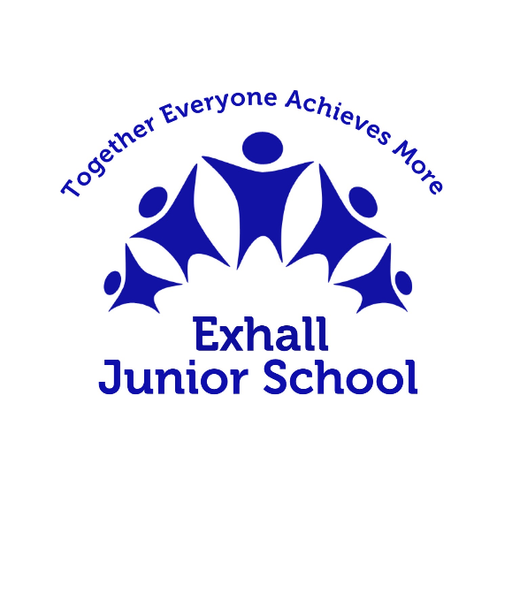

# Long Term Plan

# Music

|  |  |  |  |  |  |
| --- | --- | --- | --- | --- | --- |
| Cycle A | | | | | |
|  | Block 1 | Block 2 | Block 3 | Block 4 | Block 5 |
| LKS2 | [Body and tuned percussion](https://www.kapowprimary.com/subjects/music/lower-key-stage-2/year-4/rainforests/) (Theme: Rainforests) | [Ballads](https://www.kapowprimary.com/subjects/music/lower-key-stage-2/year-3/ballads/) | [Pentatonic melodies and composition](https://www.kapowprimary.com/subjects/music/lower-key-stage-2/year-3/festivals-chinese-new-year-2/) (Theme: Chinese New Year) |  | Instrumental scheme: [South Africa](https://www.kapowprimary.com/subjects/music/instrumental-scheme/instrumental-lessons-music-model-curriclum/south-africa-instrumental-lesson-plans/) |
| UKS2 | [South and West Africa](https://www.kapowprimary.com/subjects/music/upper-key-stage-2/year-5/south-and-west-africa/) | [Composition notation](https://www.kapowprimary.com/subjects/music/upper-key-stage-2/year-5/ks2-yr5-music-composition-and-staff-notation/) (Theme: Ancient Egypt) |  | Instrumental scheme: [Caribbean](https://www.kapowprimary.com/subjects/music/lower-key-stage/instrumental-lessons-music-model-curriclum/carribean-instrumental-lesson-plans/) | [Composing and performing a Leavers' Song](https://www.kapowprimary.com/subjects/music/upper-key-stage-2/year-6/leavers-song/) |

|  |  |  |  |  |  |
| --- | --- | --- | --- | --- | --- |
| Cycle B | | | | | |
|  | Block 1 | Block 2 | Block 3 | Block 4 | Block 5 |
| LKS2 | [Developing singing technique](https://www.kapowprimary.com/subjects/music/lower-key-stage-2/year-3/the-vikings/) (Theme: The Vikings) | [Adapting and transposing motifs](https://www.kapowprimary.com/subjects/music/lower-key-stage-2/year-4/romans/) (Theme: Romans) |  | [Traditional instruments and improvisation](https://www.kapowprimary.com/subjects/music/lower-key-stage-2/year-3/around-the-world-india/) (Theme: India) | [Changes in pitch, tempo and dynamics](https://www.kapowprimary.com/subjects/music/lower-key-stage-2/year-4/pitch-dynamics-tempo/) (Theme: Rivers) |
| UKS2 | [Blues](https://www.kapowprimary.com/subjects/music/upper-key-stage-2/year-5/blues/) | [Dynamics, pitch and tempo](https://www.kapowprimary.com/subjects/music/upper-key-stage-2/year-6/coast-fingals-cave-by-mendelssohn/) (Theme: Fingal's Cave) | [Theme and Variations](https://www.kapowprimary.com/subjects/music/upper-key-stage-2/year-6/pop-art/) (Theme: Pop art) |  | [Composition to represent the festival of colour](https://www.kapowprimary.com/subjects/music/upper-key-stage-2/year-5/holi-festival/) (Theme: Holi festival) |